1. CONTACT DETAILS
Family Name: | First Name:
Title: | Date of birth (dd/mm/yyyy):
Street + number: | City:
Postal code: | Country:
Primary e-mail address: | Alternative e-mail address:
Telephone: | Mobile number:

2. AFFILIATION DETAILS

New Affiliation Affiliation Renewal
Type of Affiliation
Fees (excl. Belgian 21% VAT)
€ 125 Supporter | € 250 Promoter | € 500 Partner
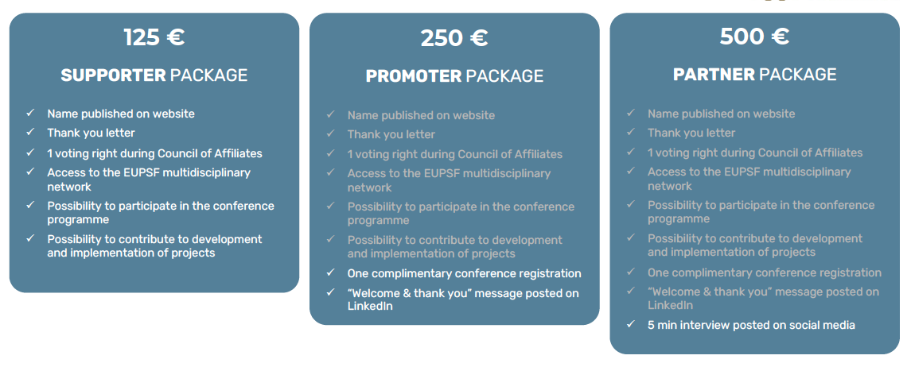

3. PAYMENT DETAILS

Please note that affiliation membership runs from January to December. Affiliation will only become active once bank transfer payment has been received by the EUPSF. Payment can only be made via bank transfer (no credit cards or cheques) upon receipt of the invoice.

4. PERSONAL DATA PROTECTION
In line with the enclosed data protection policy, I agree to allow European Patient Safety Foundation (EUPSF) to:
Process my personal data, collected electronically or on paper, received with this application and in the context
of future events.
Use my preferred mailing address for receiving EuPSF’s mailings and Newsletters.
Photograph me at formal and social events and to publish the photos on the EuPSF web site.
EUPSF PERSONAL DATA PROTECTION POLICY
On the 25th May 2018, the European Union's General Data Protection Regulation (GDPR) came into force, which provides you with rights to control the collection and use of your personal data. Your privacy is important to EUPSF, so we have developed this privacy policy to provide visibility about what we collect and how we process your personal data as a member of EUPSF.
- Personal data shall only be collected from the members in order to allow EUPSF to meet its objectives as stated in the By-laws of the Foundation.
- Personal data shall be processed only if the purpose of the processing could not reasonably be fulfilled by other means.
- In order to ensure that the personal data are not kept longer than necessary, time limits will be established by the Board of Directors for erasure in an appropriate manner.
- Every reasonable step will be taken to ensure that personal data which is inaccurate is rectified or deleted.
- Personal data shall be processed in a manner that ensures appropriate security and confidentiality of the personal data, including the prevention of unauthorised access to or use of personal data and the equipment used for the processing.
- Personal data will not be transferred to other organisations, unless this is necessary in order to fulfil the objectives of the association, or EUPSF is obliged to do so by an applicable law.
- Members have the right to request access to their personal data, require it to be rectified or deleted ("the right to be forgotten") and to have it provided to them in a machine-readable format ("data portability").
All questions regarding the implementation of the GDPR should be addressed to secretariat@eupsf.org.

Name:  Signature: | Date: 12/12/2023

